**DAILY ONLINE ACTIVITIES SUMMARY**

|  |  |  |  |  |  |
| --- | --- | --- | --- | --- | --- |
| **Date:** | | **01/07/2020** | **Name:** | **JASLINE SHARON TAURO** | |
| **Sem & Sec** | | **4th sem, A Section** | **USN:** | **4AL18CS029** | |
| **Online Test Summary** | | | | | |
| **Subject** | **-------** | | | | |
| **Max. Marks** | **--** | | **Score** | **--** | |
| **Certification Course Summary** | | | | | |
| **Course** | | CLOUD SUPPORT ENGINEER | | | |
| **Certificate Provider** | | **AWS Educate** | **Duration** | | **4 hrs.** |
| **Coding Challenges** | | | | | |
| **Problem Statement:**  Given two lists, sort the values of one list using the second list. | | | | | |
| **Status: EXECUTED** | | | | | |
| **Uploaded the report in GitHub** | | | **YES** | | |
| **If yes Repository name** | | | <https://github.com/jaslinesharontauro/Python-coding> | | |
| **Uploaded the report in slack** | | | **YES** | | |

Online Test Details: (Attach the snapshot and briefly write the report for the same)

Certification Course Details: (Attach the snapshot and briefly write the report for the same)

Coding Challenges Details: (Attach the snapshot and briefly write the report for the same)

CERTIFICATION COURSE DETAILS:

Today I have continued the course “Cloud Support Engineer” by AWS Educate. In this course today I learnt about ‘Network’ and ‘Software Development’. Today I have completed two modules of this course, And I have also completed the assessment of these modules.

## 

## 

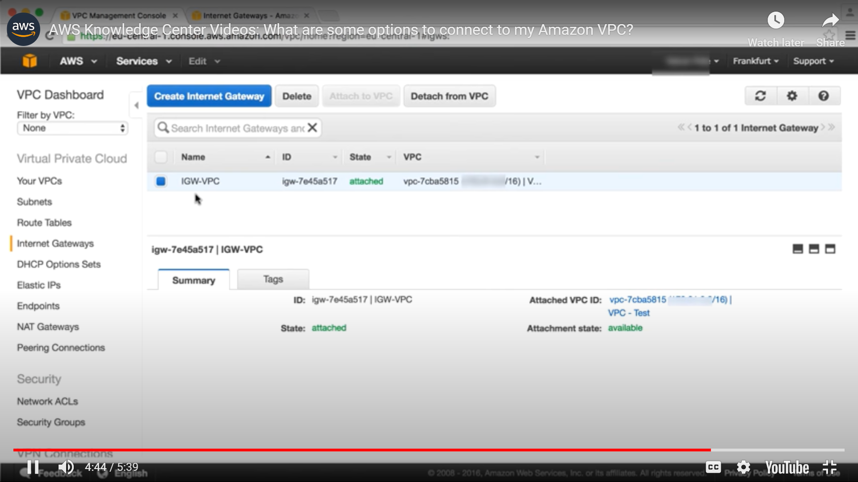

**Coding Challenges Details:**

**Problem Statement:**

Given two lists, sort the values of one list using the second list

**Examples:**  
Input:  
list1 = ["a", "b", "c", "d", "e", "f", "g", "h", "i"]

list2 = [ 0, 1, 1, 0, 1, 2, 2, 0, 1]  
Output: ['a', 'd', 'h', 'b', 'c', 'e', 'i', 'f', 'g']

Input:

list1 = ["g", "e", "e", "k", "s", "f", "o", "r", "g", "e", "e", "k", "s"]

list2 = [ 0, 1, 1, 0, 1, 2, 2, 0, 1]

Output: ['g', 'k', 'r', 'e', 'e', 'g', 's', 'f', 'o']

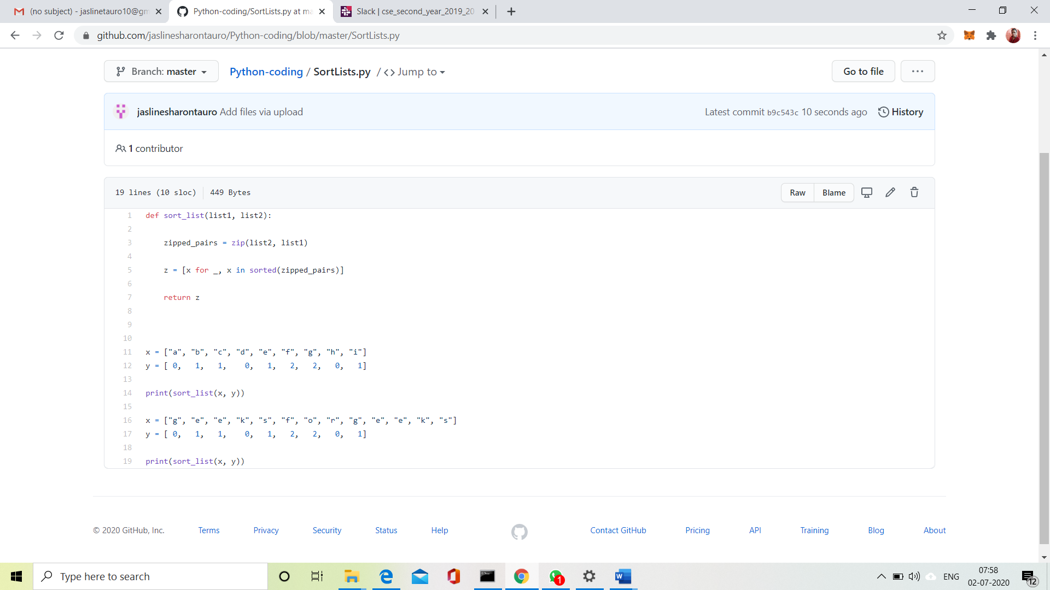

**Solution:** Uploaded it in GitHub